**Megha Sharma**

**Pavani Sree Lakshmi Penumathsa**

**Reshma Reddy Thumma**

**Vinutha Nuchimaniyanda**

**Project Report E-Smart Application**

**Increment-3**

CS-5551 ASE

We have been able to implement the following features as part of the first ,second and third increments of the project.

1. User login, registration & validation
2. Home Page
3. Energy Analyzer includes
   1. Energy utilization analysis with Green Button file (annual and monthly utility data analysis)
   2. Energy utilization analysis without Green Button file
4. Home Comfort
5. Find Energy efficient Neighborhood
6. Survey based Budget my year, Recommendation and Tip of the day
7. My Community
8. Discussion Board

**Web Client/Mobile UI Design**

To design the UI, we have used a combination JQuery, HTML5 and CSS. Most of the features have been supported by google and other web apis.

**Class Diagram**

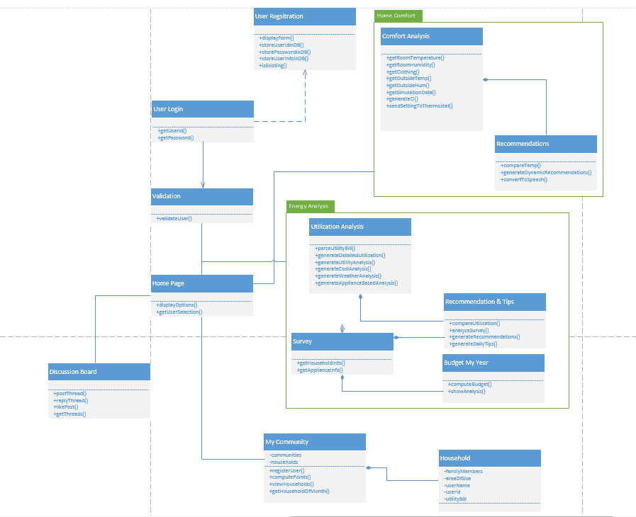

**Sequence Diagrams**

1. User Login and Service request

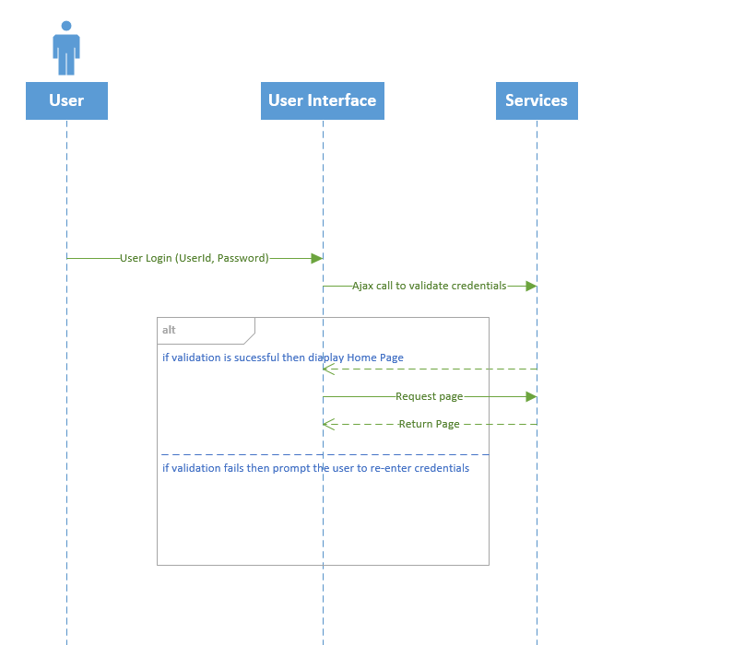

1. User Registration

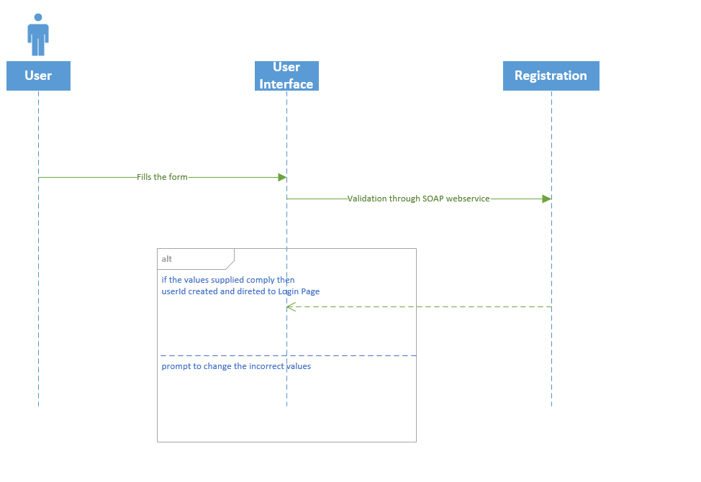

**System Architecture Design**

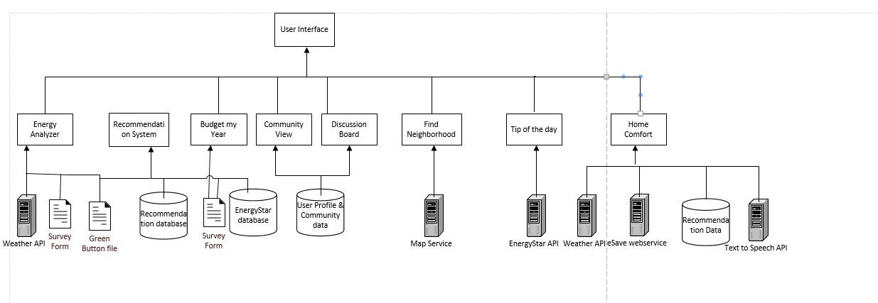

**Implementation Details**

The details of the features are below:

**1) User Login & Registration**

**Webservices/API:**

* We plan to use SOAP webservices to perform verification of user credentials and for storing user credentials in the database.

**Design & Implementation details:**

This page will allow the user to login to the E-Smart website. The validation is done based on the username and password entered by the user. If the validation is successful, it navigates to the website’s Homepage. If either username or password doesn’t match it shows the error message and will not allow the user to login to the website.

**Login page:** This page will allow the user to login to the E-Smart website. The validation is done based on the username and password entered by the user. If the validation is successful, it navigates to the website’s Homepage. If either username or password doesn’t match it shows the error message and will not allow the user to login to the website.

**Sign up page:**

This page allows new users to register on **E-Smart** website.

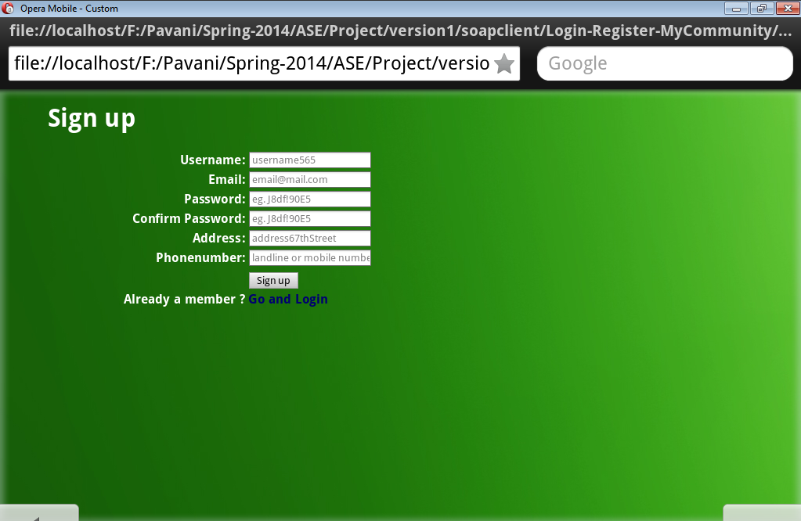

During sign up, if the user enters password less than 8 characters it throws an error “Password should be atleast 8 characters” and doesn’t allow to proceed further, until the user enters valid password.

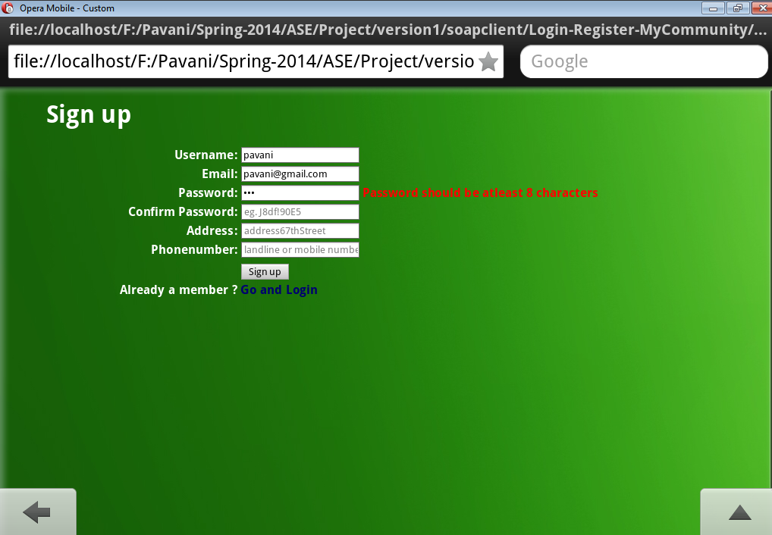

During sign up, the valid password should contain atleast one upper case, one lower case, one numeric and one special character. If the user enters invalid password it throws an error “Invalid Password” and doesn’t allow to proceed further, until the user enters valid password.

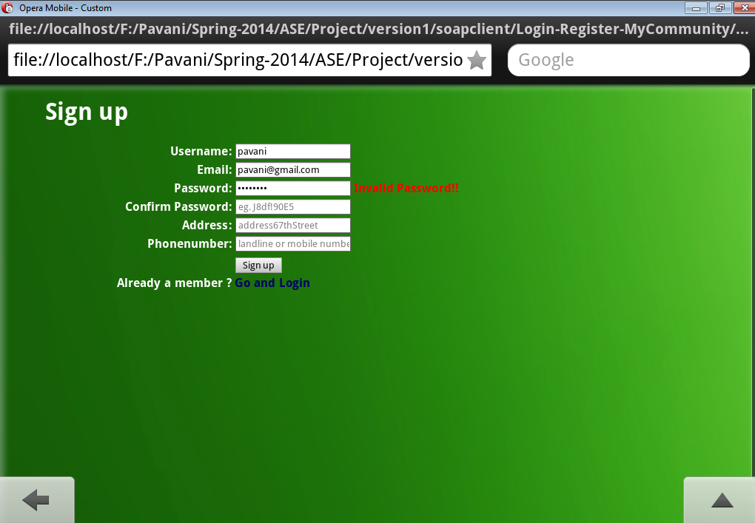

During sign up, the password and confirm password values should match otherwise it throws an error “Passwords does not match. Please re-enter” and doesn’t allow to proceed further, until the user enters valid password.

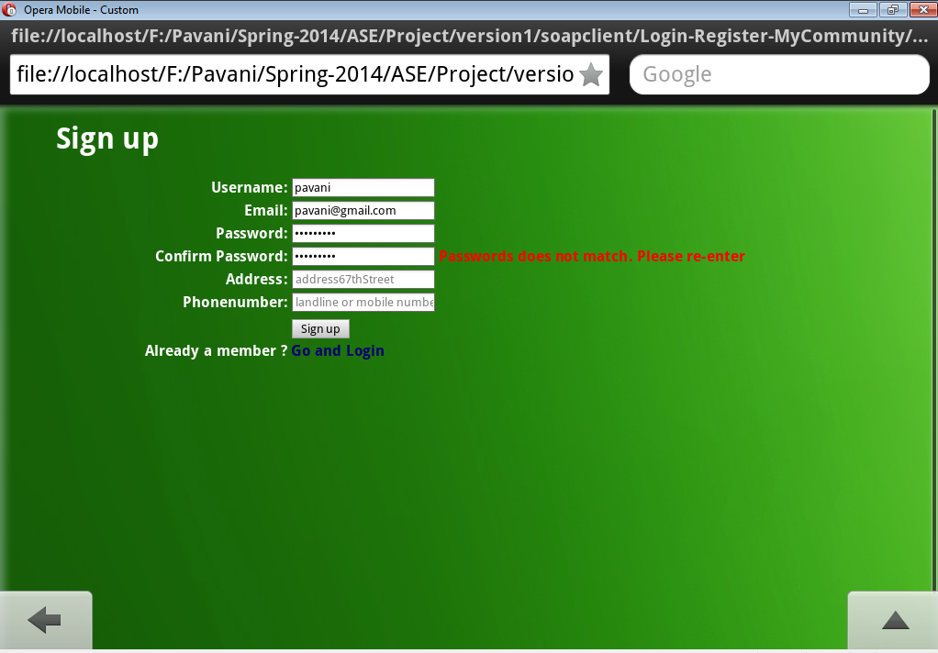

During sign up, if the user enters all details correctly and clicks on signup button, he will be navigated to the Login page.

User can directly go to Login page by clicking on the Go and Login button.

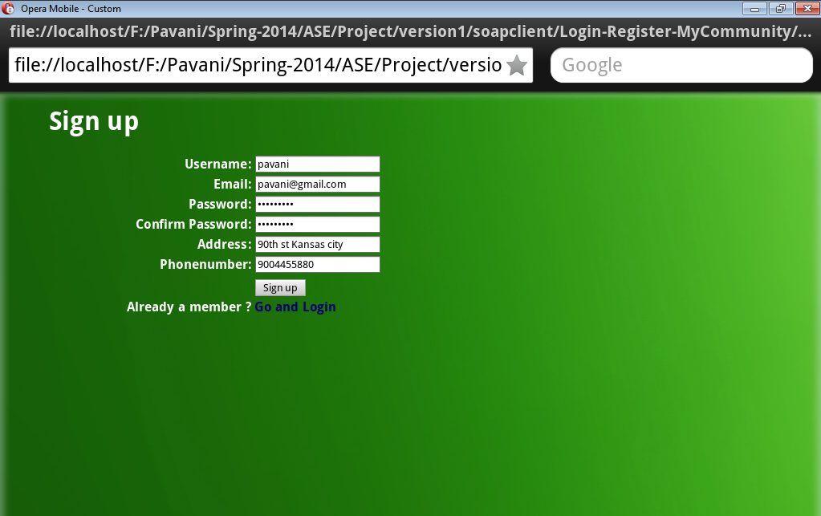

**Login page:** This page will allow the user to login to the E-Smart website. The validation is done based on the username and password entered by the user. If the validation is successful, it navigates to the website’s Homepage.

If the user is new, he can go to sign up page and register by clicking on the Register button.

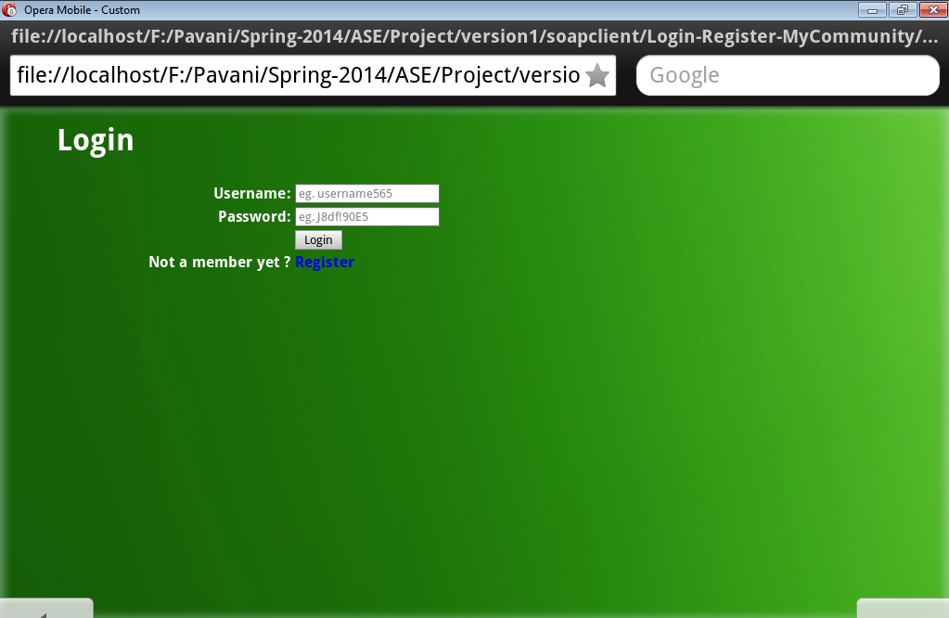If either username or password doesn’t match it shows the error message “Invalid ID or Password. Please re-enter” and will not allow the user to login to the website.

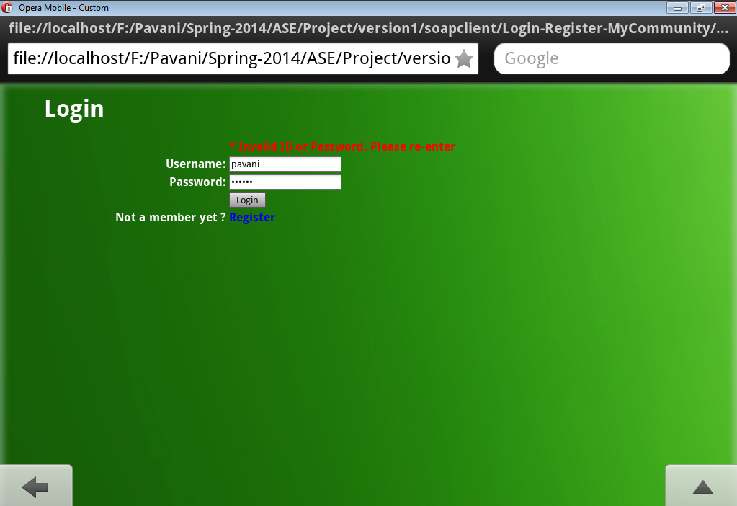

The registered user details are stored in **users** table in the sql server database.

While loging in the username and password values are verified with the values that already exist in the users table.

Once the user enters valid username and password he will be navigated to the **Home Page**.

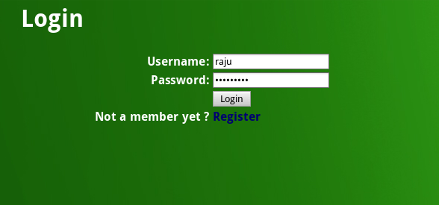

**2) Homepage**

On successful login the user is directed to the E-Smart homepage.

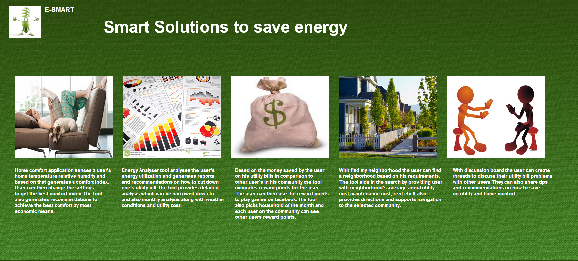

User Clicks on the images on the page which will then direct him to the next page he wants to visit. Home page links to Home Comfort, Energy Analyzer, Discussion Board, Find My Neighborhood, Survey pages.

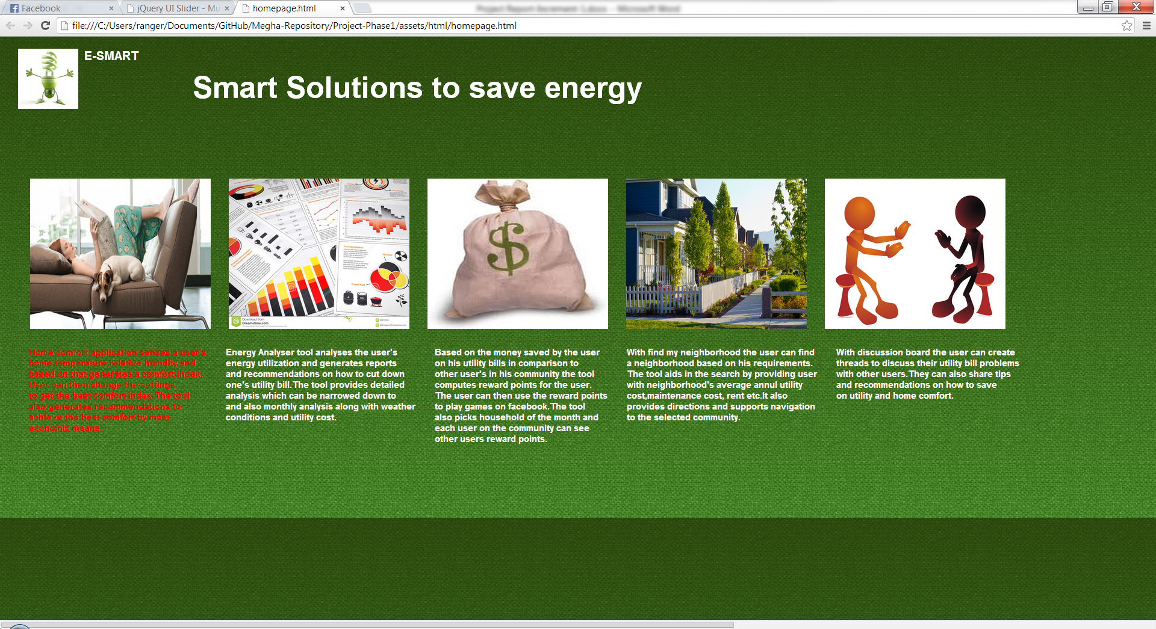

**2) Energy Analyzer**

Charts

Import Existing Services/API

1. Google Visualization API Source
2. Visualization ComboChart for Energy Analysis Monthly data.
3. Visualization AreaChart for Cost difference data
4. Google Maps API for maps in find energy efficient houses
5. Google Maps directions API in find energy efficient houses

Detail Design of Services

User will be navigated to the first page of Energy Analyzer from the home page. The first page consists of textboxes that user has to fill in to get appropriate recommendations. The complete functionality of will be completed by next increment.

After filling the details, user has an option to choose about whether he wants the charts to be generated for the green button data or non-green button data.

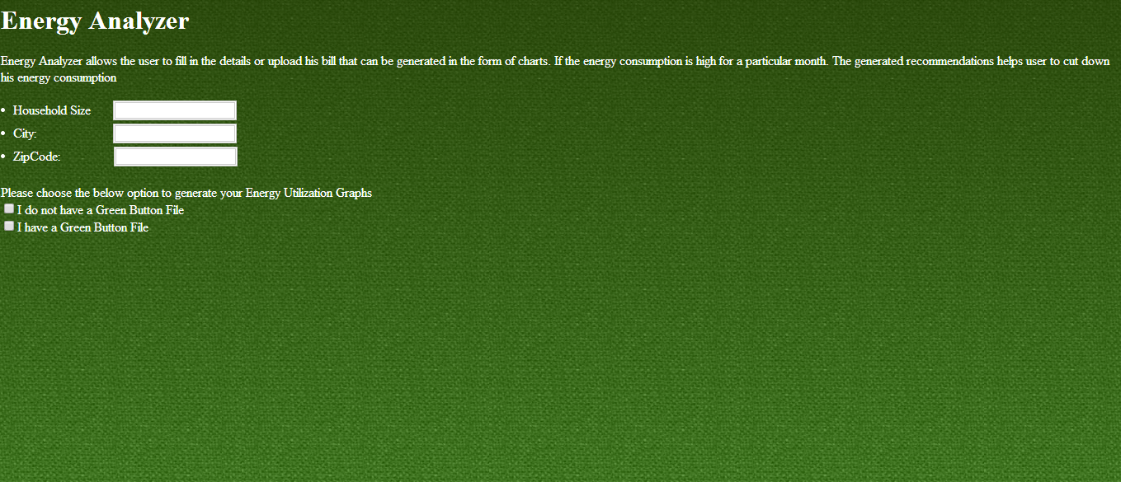

If user checks the I do not have green button file checkbox, he will be provided with the option of filling in the values in kilowatts for each month that will be generated as a graph.

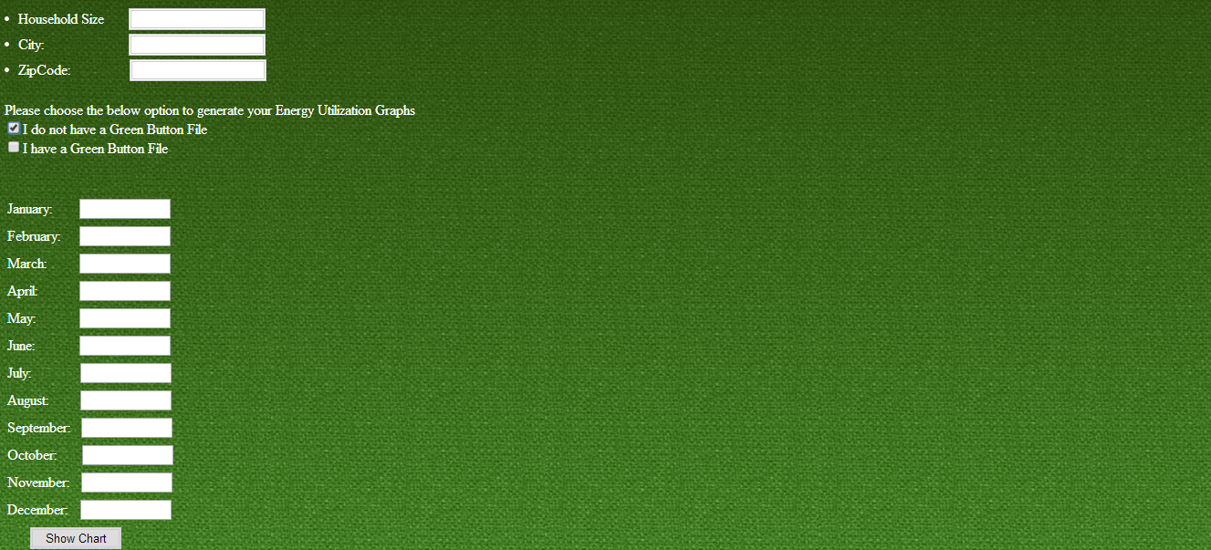

Below chart is generated once the user fills the values in the textboxes provided and show chart button lets the chart to be generated.

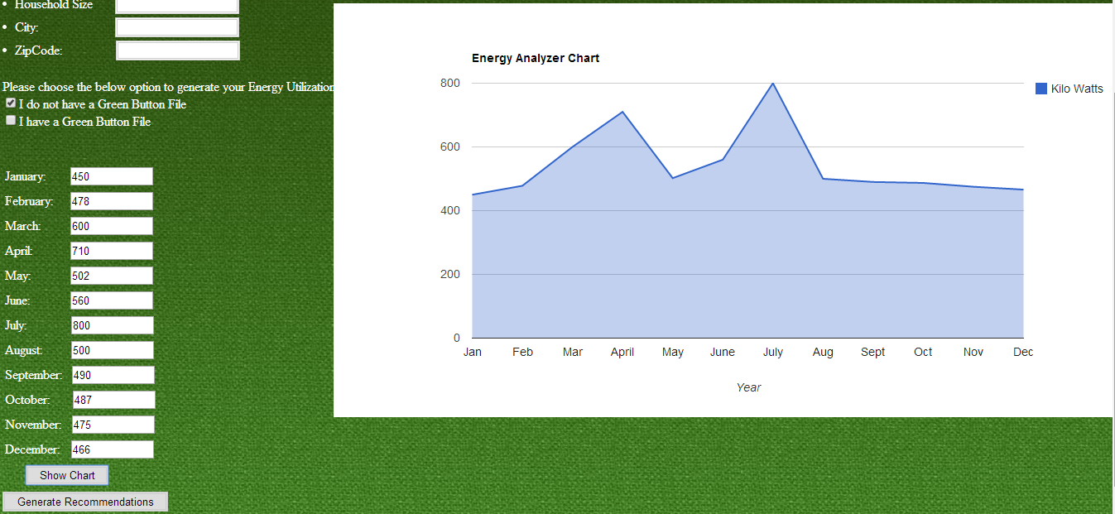

Generate recommendations button will generate energy saving tips for the user based on the chart. Recommendations would be for Spring/Summer or for Fall/Winter depending on the kw values.

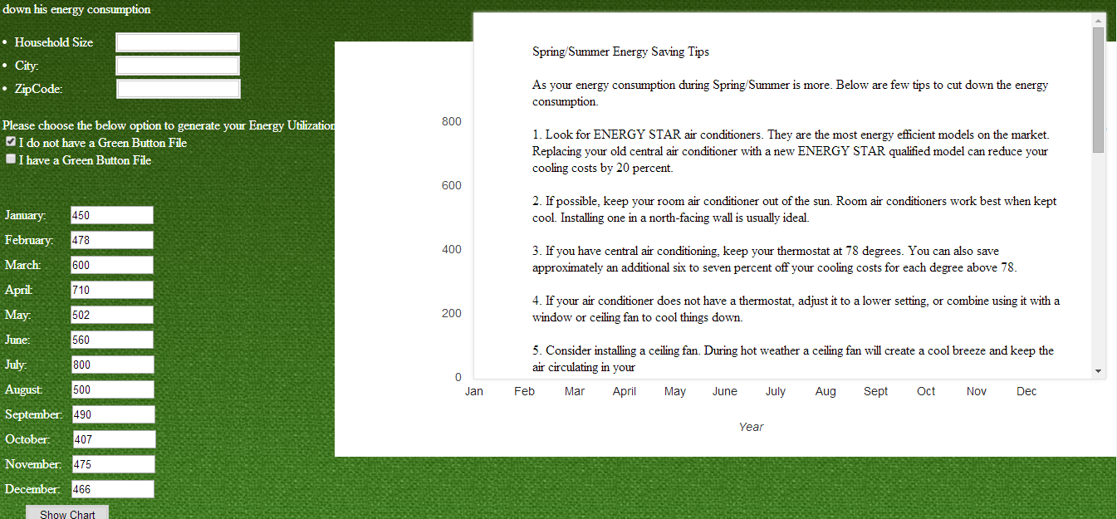

If the user checks, I have Green Button File checkbox. He will be navigated to the dynamic charts page where he can upload the file and two charts are generated.

1. Energy analysis chart with variation in Temperature
2. Cost analysis chart

These charts are for 45 days of data. Below is the screenshot of energy analysis chart with variation in temperature.

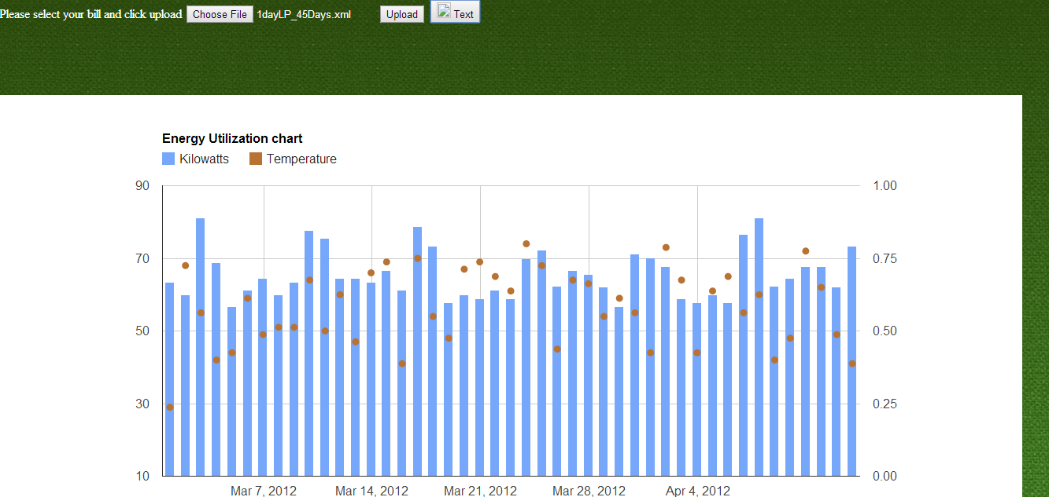Below is the screen shot for the variation in the cost depending on the energy consumed for each day up to 45 days

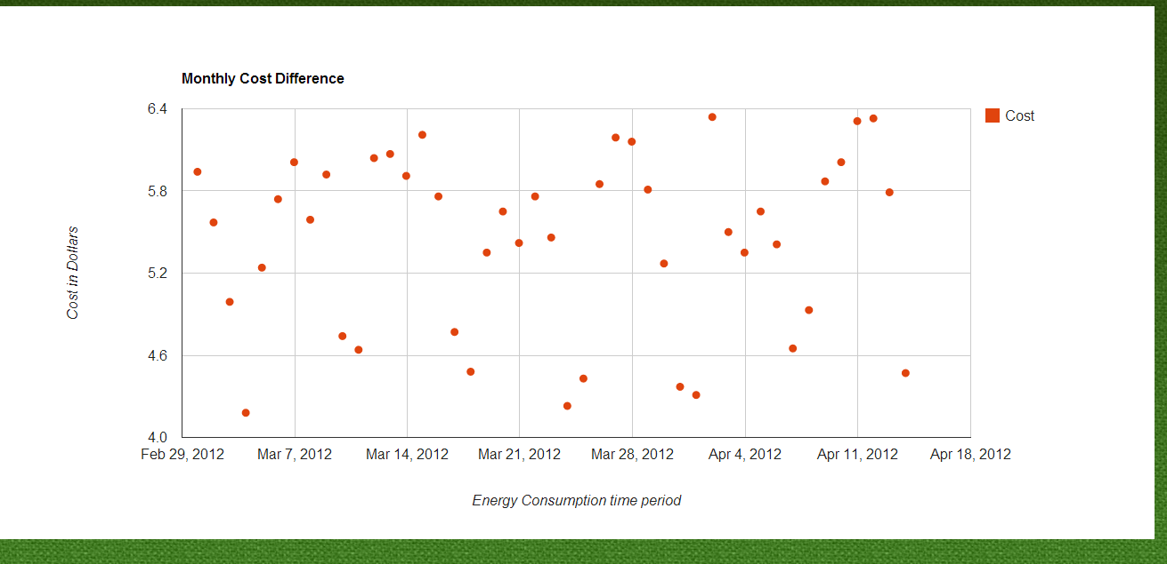

1. Detailed View:

After user selects green button file, he will be asked to browse ad upload a file as below

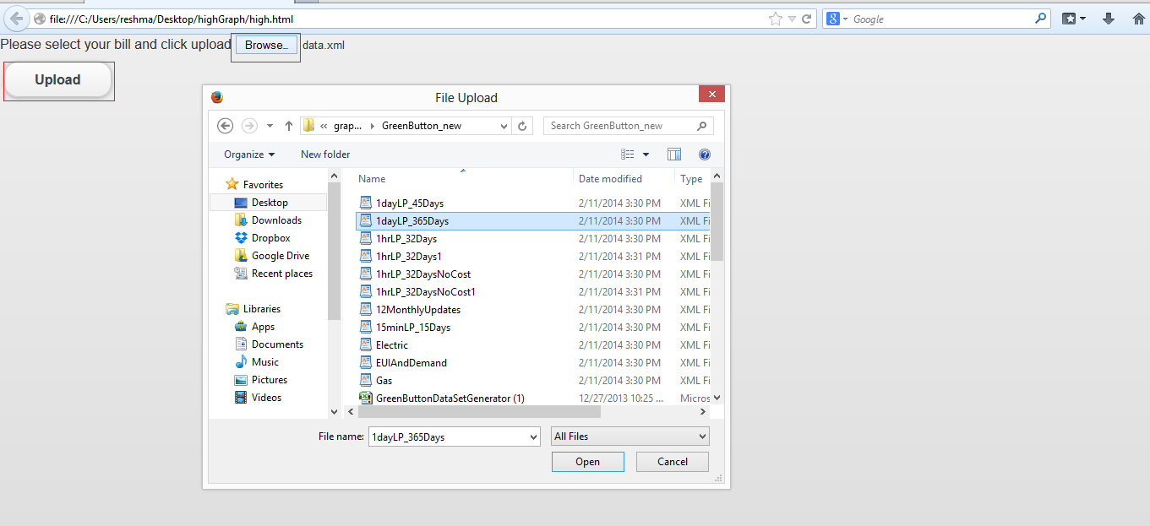

Once user clicks Upload button a detailed graph will be generated for whole year with the energy and cost value of each day.

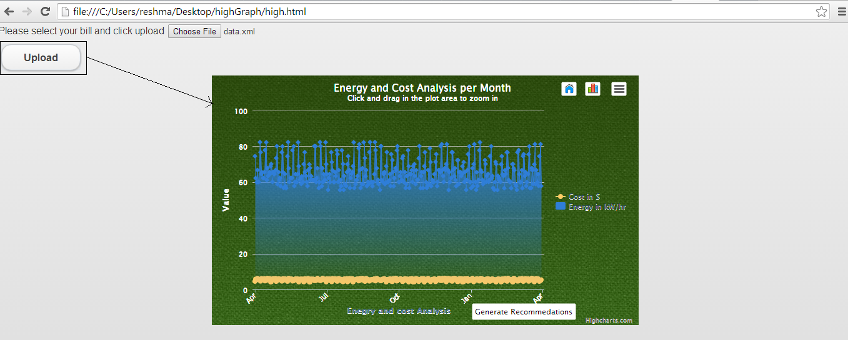

User will have an option to select only cost or energy as below

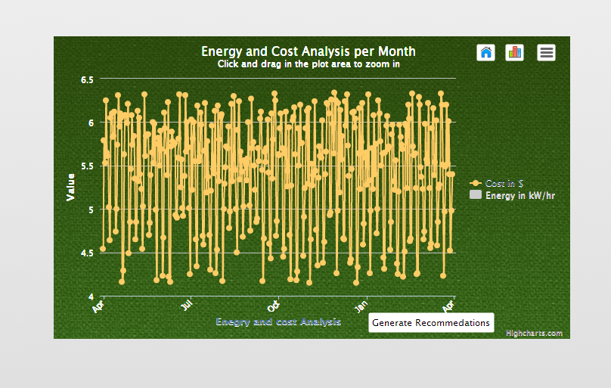

If user wants to conserve energy he can click “Generate Recommendations” He will be given a set of Recommendations as below.

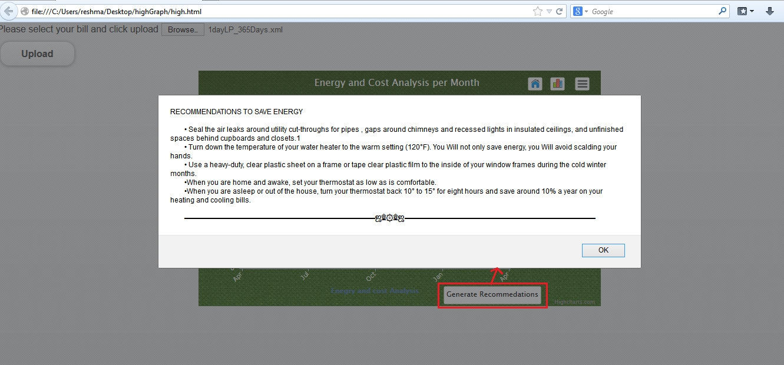

**3) Home Comfort**

**Webservices/API:**

* The geocode function supported by the browser has been used to detect user’s current location.
* The weather webservice by wunder “api.wunderground.com” has been used to populate the outside temperature and humidity.
* The jQuery UI sliders have been used for creating sliders on the home comfort page.
* The “google.visualization.Gauge” has been used to create the comfort index gauge.
* The text to speech service from tts.com has been used to convert to written recommendations to speech.

**Design & Implementation details:**

User Clicks on the Home Comfort Image.



The Page displays the user’s current home temperature and humidity and computes the Comfort Index (Comfort Index computation using formulae is yet to be implemented) of his home environment. This page also shows the outside temperature and humidity and displays a message providing an explanation of the comfort index.

If the comfort index is outside the comfort zone (in green) then it also shows a set of recommendations to make the comfort index fall into green zone. These recommendations are created by performing computation on his current home environment.

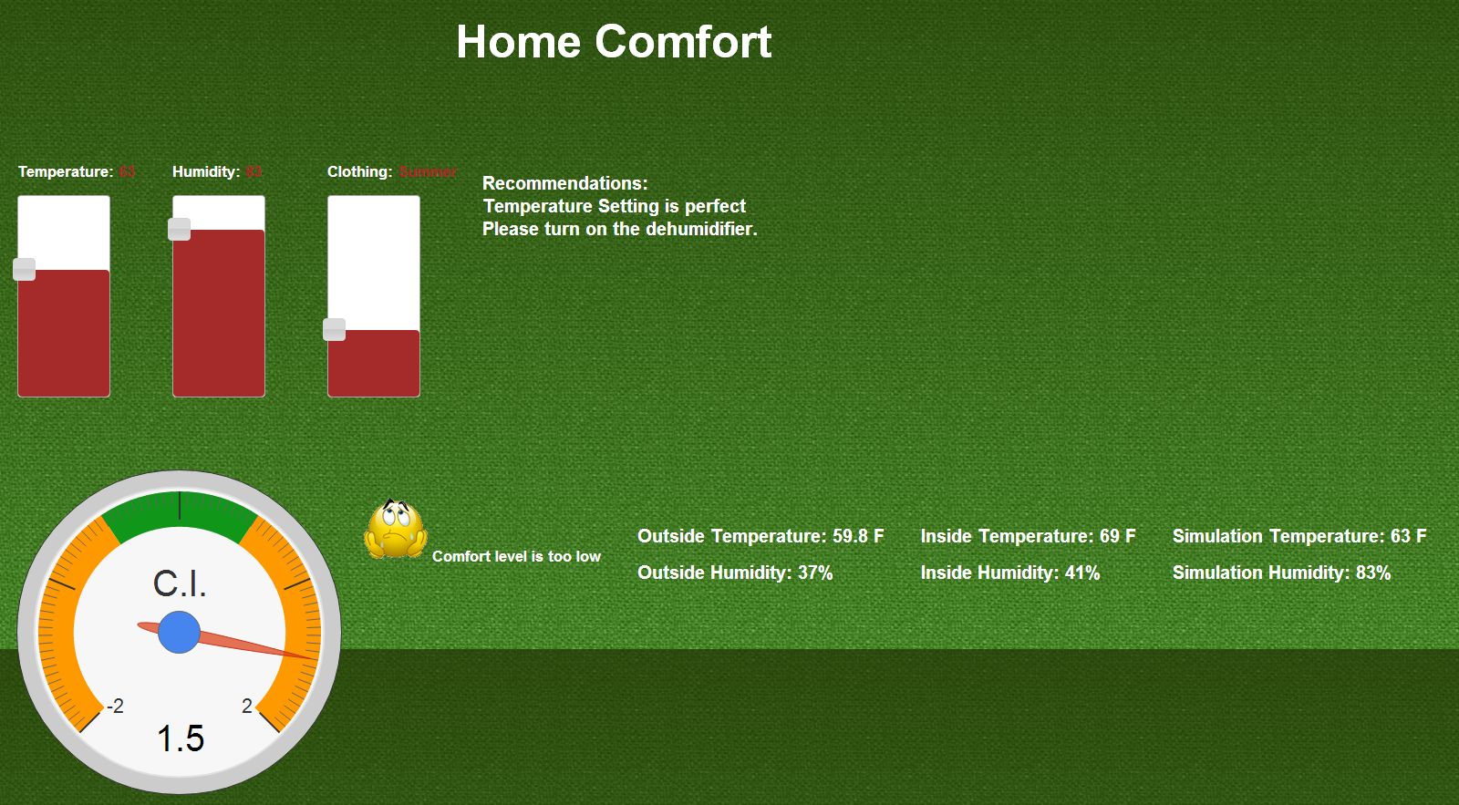

The user then tries to change the temperature, humidity and clothing based on the recommendations and a new comfort index is computed and displayed. The comfort index is now in the green zone so the user’s home environment is now comfortable.

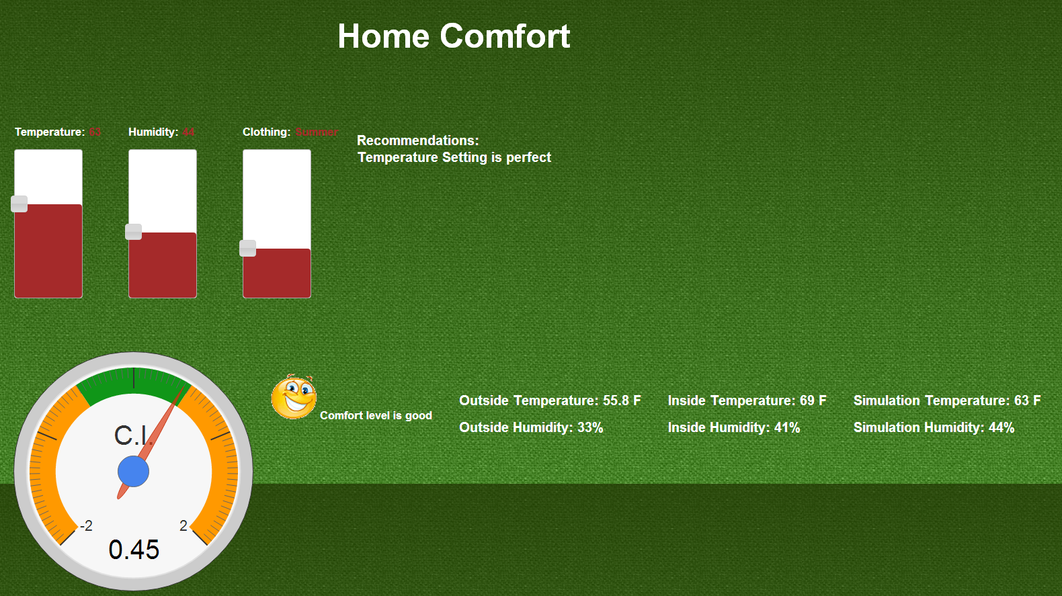

If the user sets the temperature too high or too low then the system prompts an alert message.

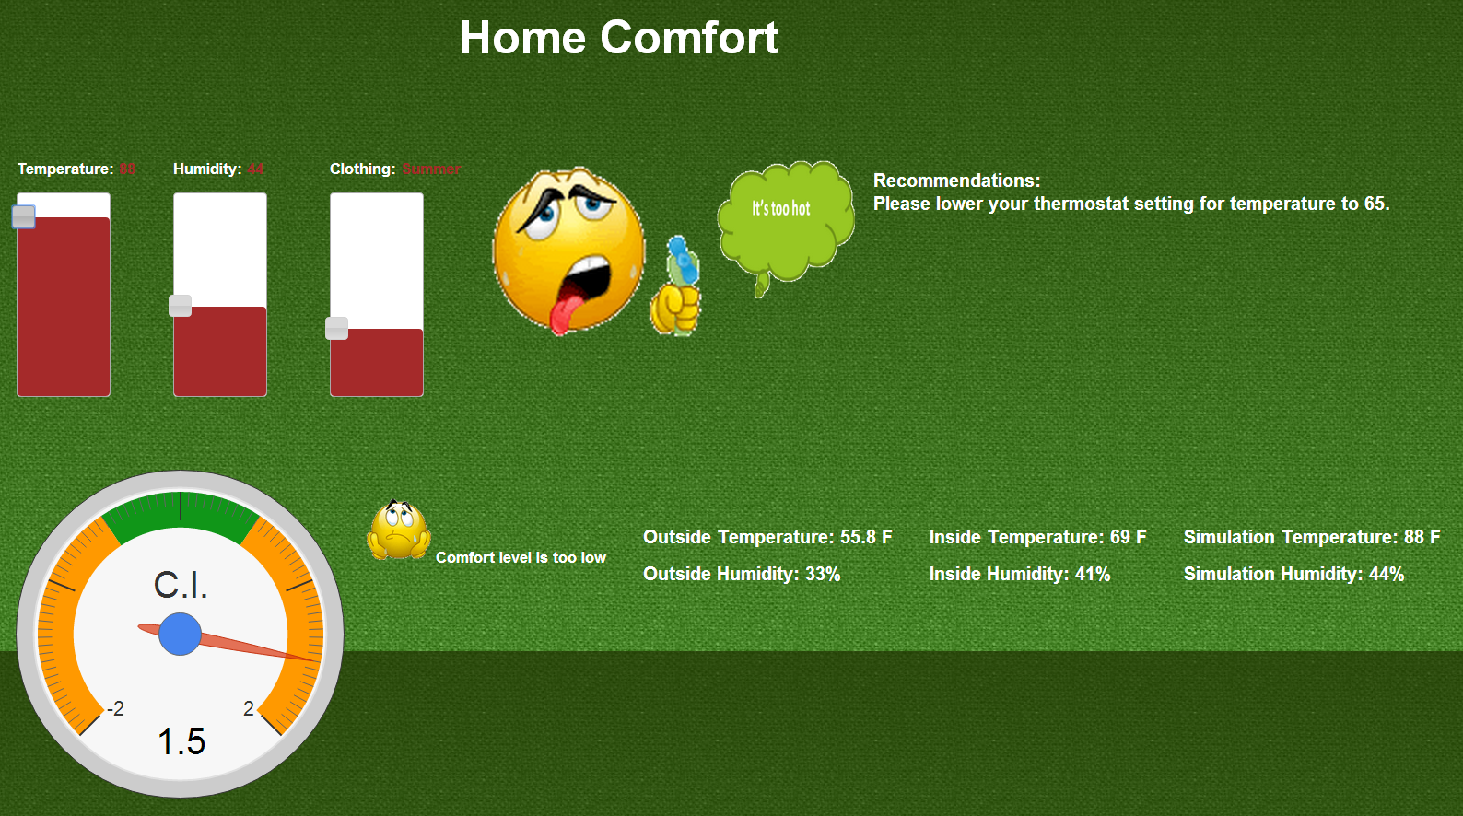

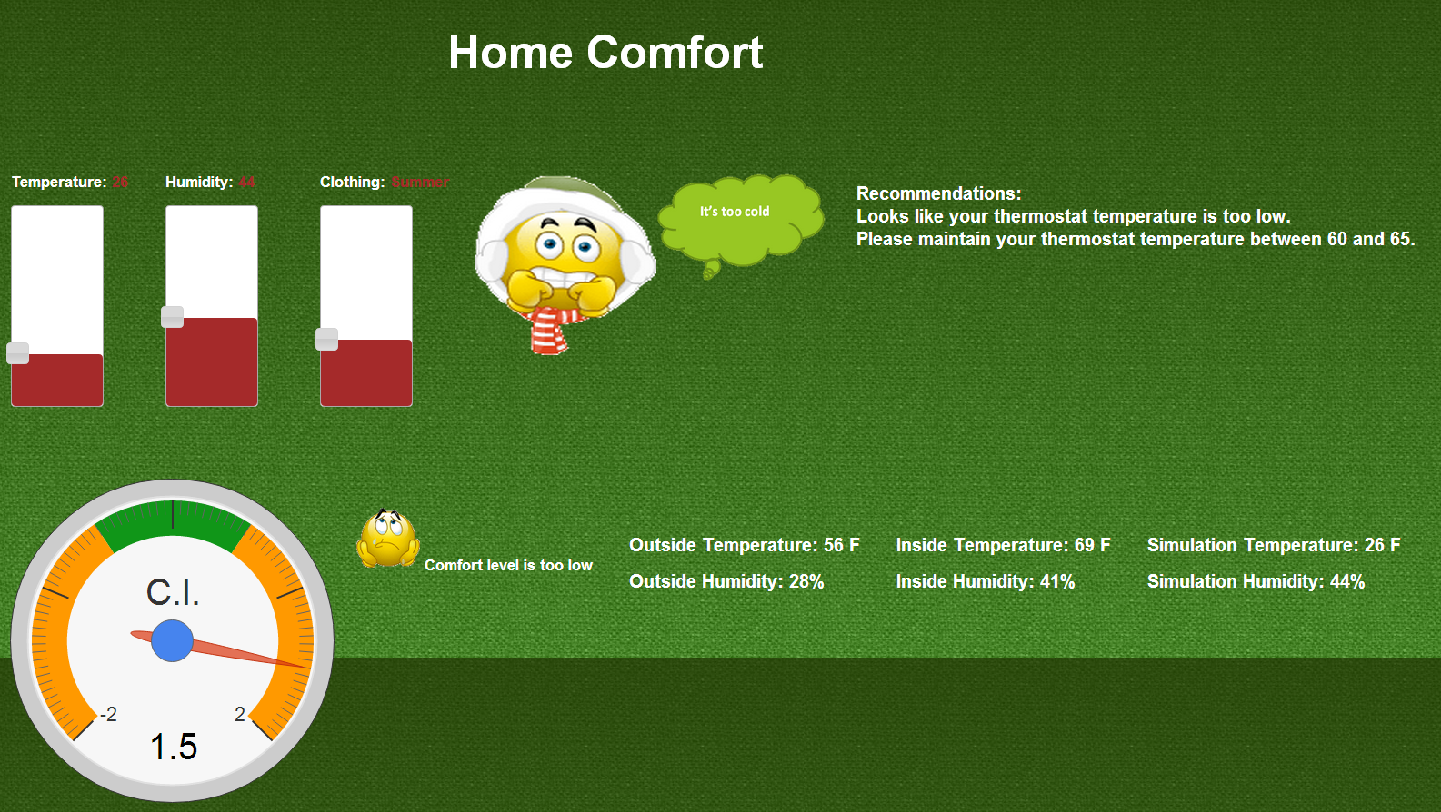

**4.Energy Efficient Houses**

Finding energy efficient houses in major areas of the kansas. This feature allows user to select energy efficient houses in major areas of Kansas. Most of the houses are under construction. Information is collected from major real estate websites like Zillows ..etc. This feature allows the user to look at the notes available for each house where the list price and address is provided along with important notes about the house . User can see the directions for each house with the street view of the house.

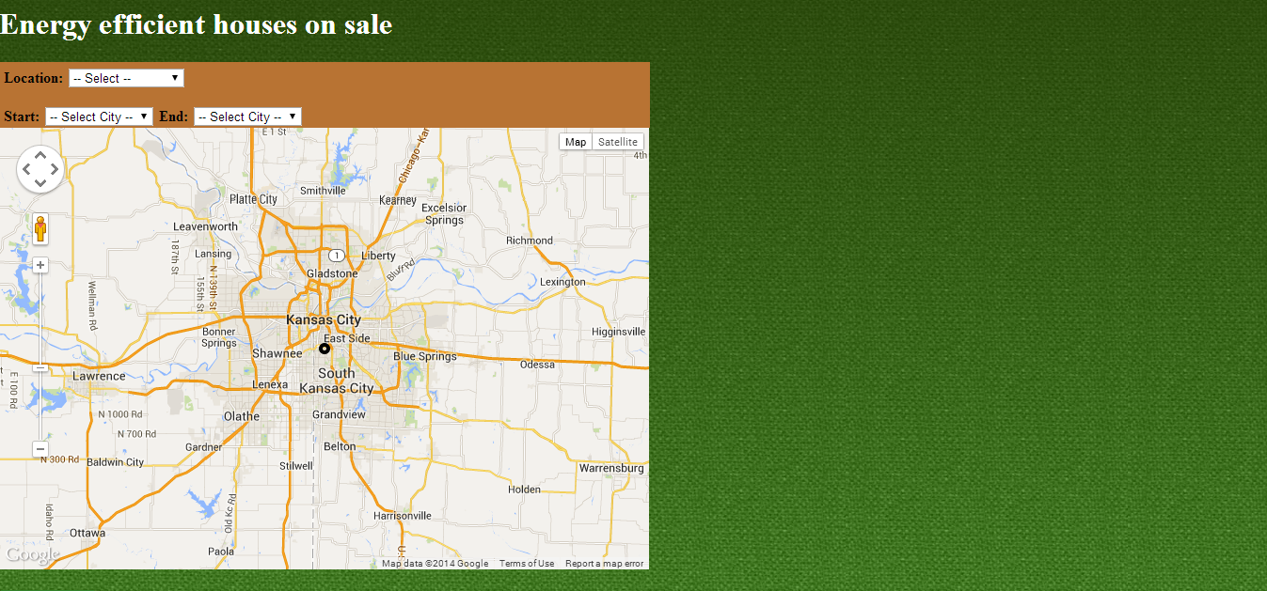

Below is the screenshot for number of different cities that user can find the energy efficient houses

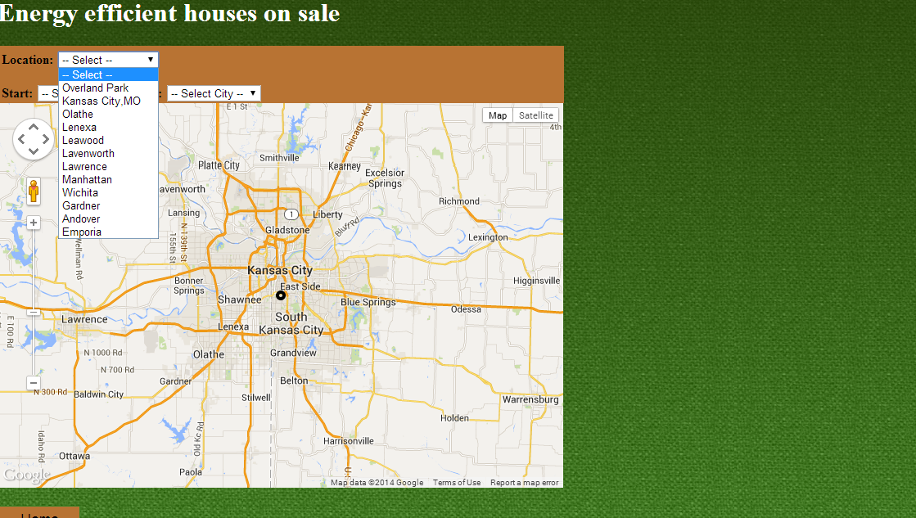

List of notes is available on the right side of the page with the details of each house in a city selected from dropdown. Notes are implemented using soap database.

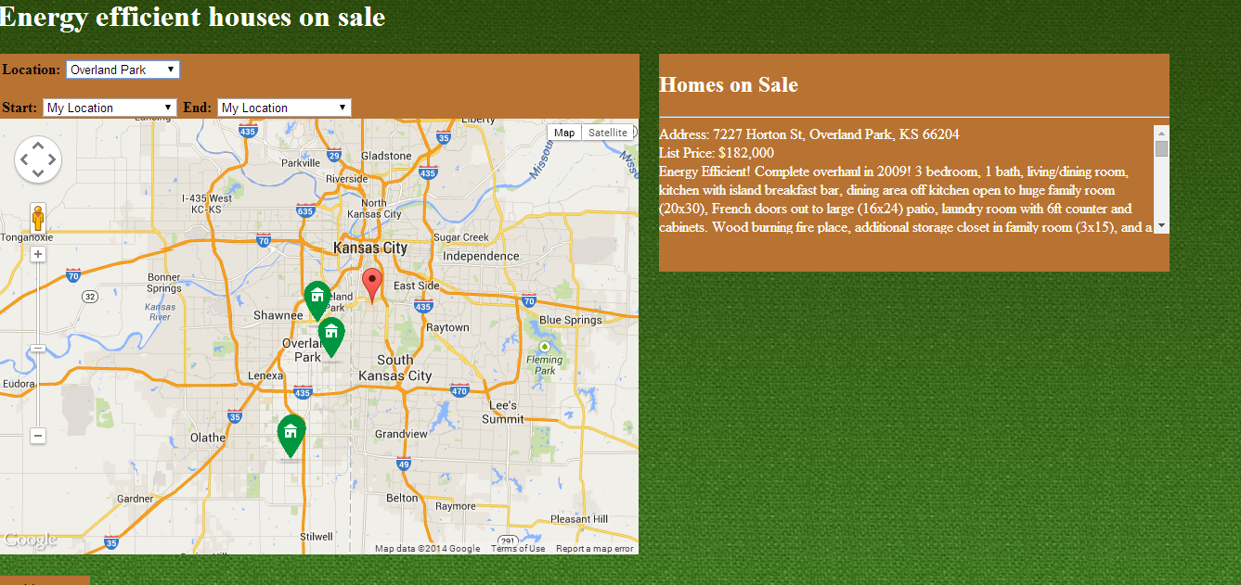

Start and End position on the map panel lets the user to see the direction for a particular location

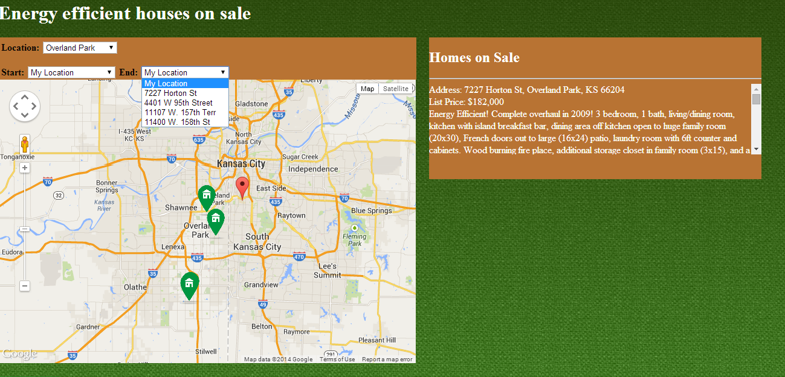

My location is configured to UMKC latitude and longitude.

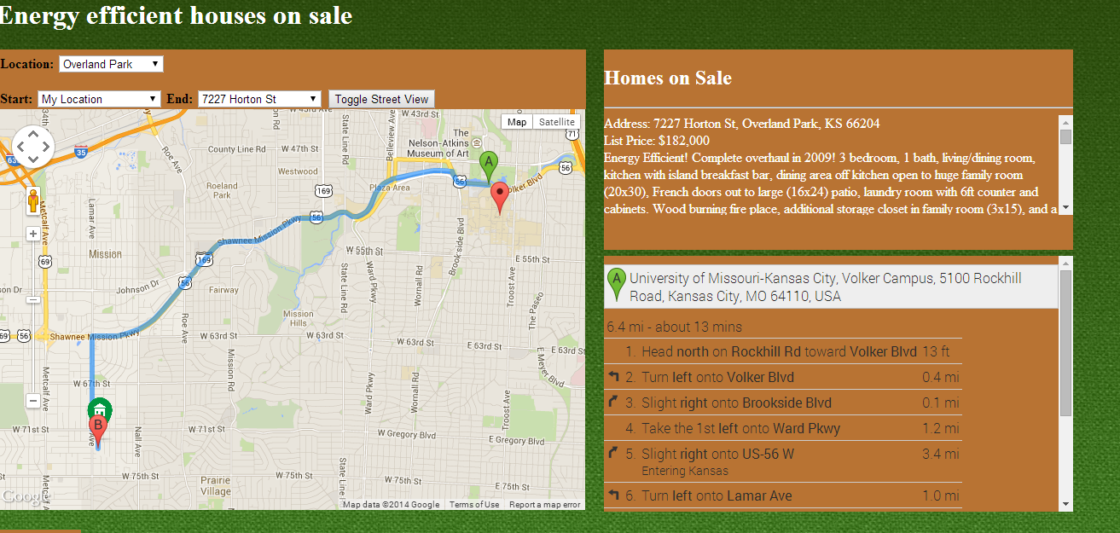

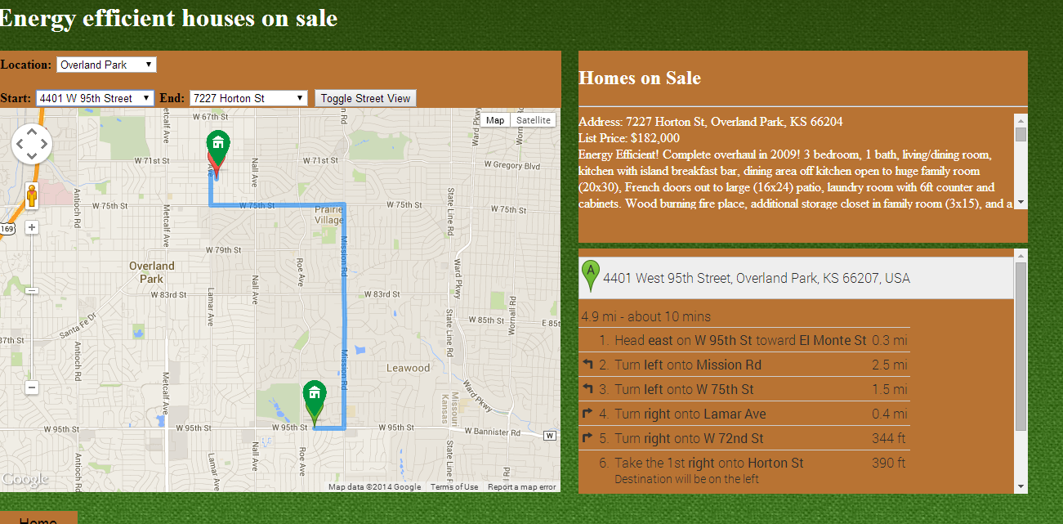

Toggle street view button is configured for the house at the End address where user can view the street location of the house

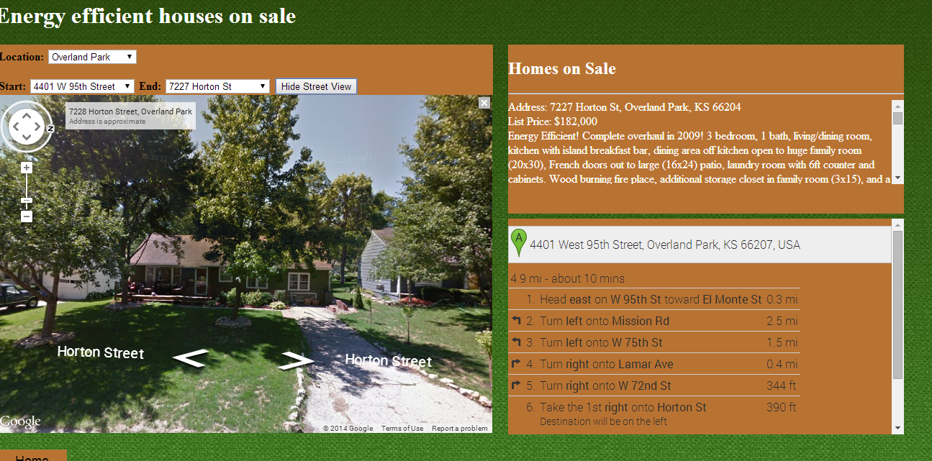

**6) Survey based Budget my year, Recommendation and Tip of the day**

**Webservices/API:**

* In future we will be using EnergyStar API to determine each appliance’s approximate energy consumption.
* Google visualization api has been used to generate charts.
* jQuery toggle used in recommendations page.

**Design & Implementation details:**

User clicks on the Budget My Year option which takes him to the survey page.

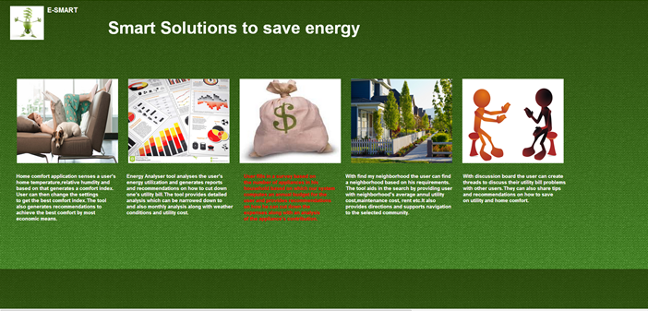

Below is the survey page where user can gets the options to fill household survey and Appliance Information.

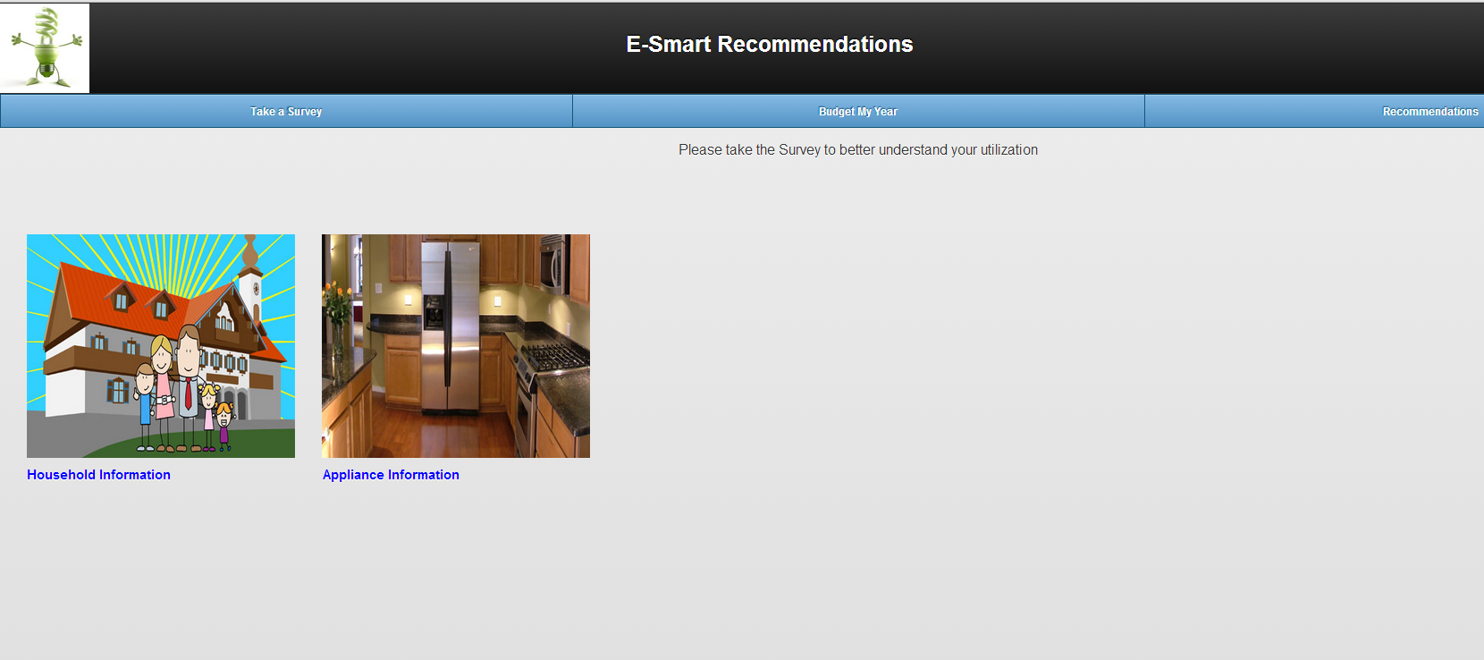

Below is the Household information part of the survey.

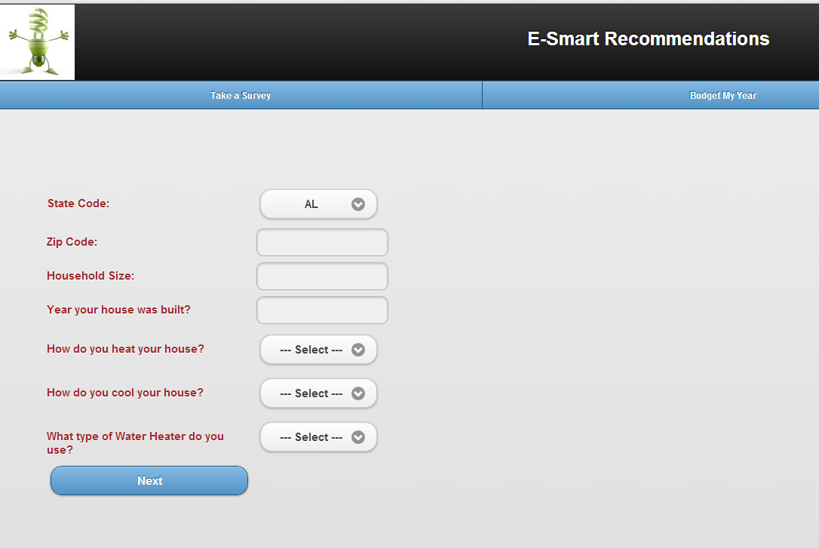

The next page takes him to the appliance based survey.

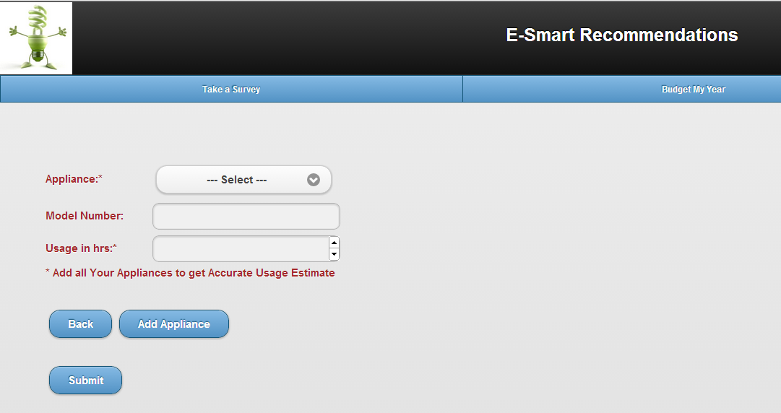

After entering all the appliances and clicking on submit, the system displays the below page.

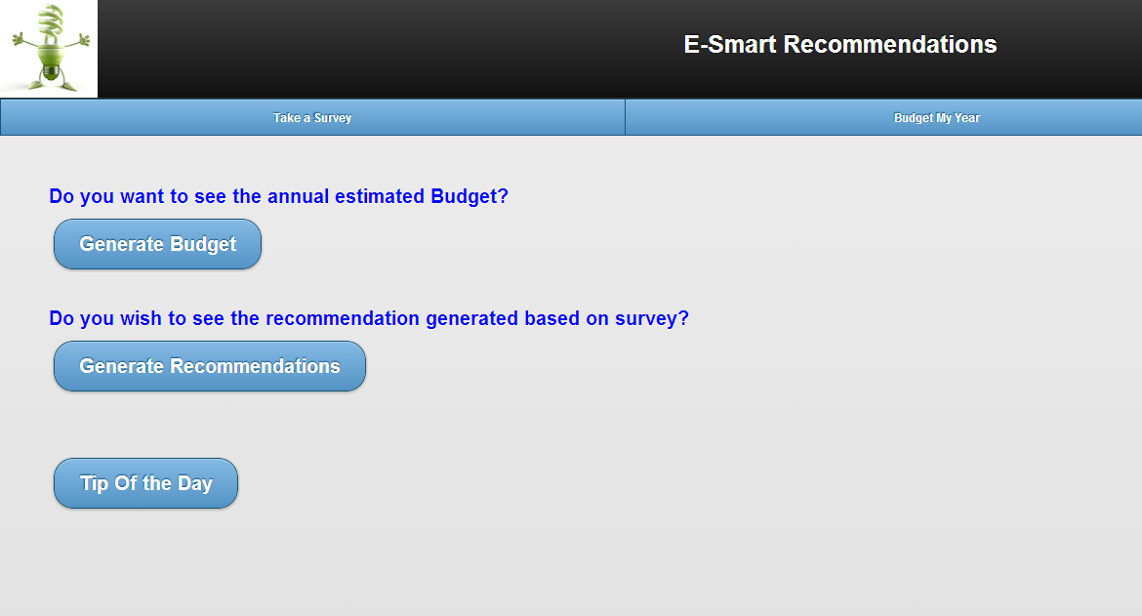

On clicking generate Budget, the system computes the user’s estimated budget generated based on the survey.

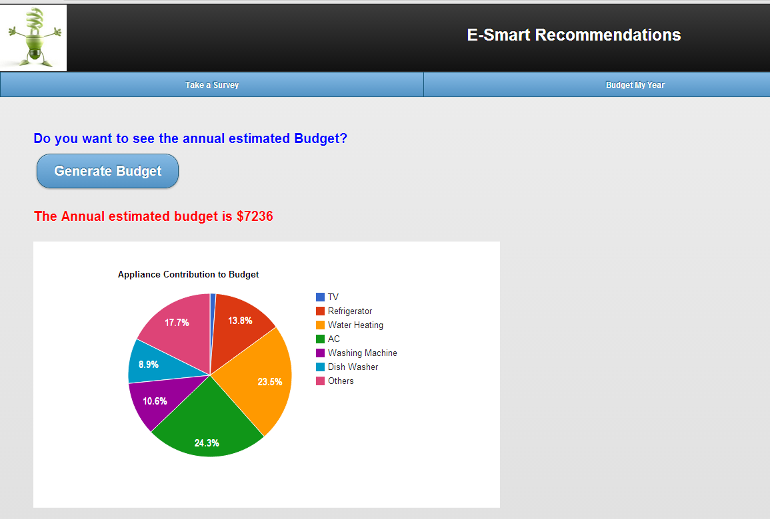

Clicking on generate recommendations takes him to another page which displays a set of appliance utilization recommendations generated based on the survey. A toggle feature in jQuery is used while designing this application. User can have a choice of selection which appliance recommendation he needs.

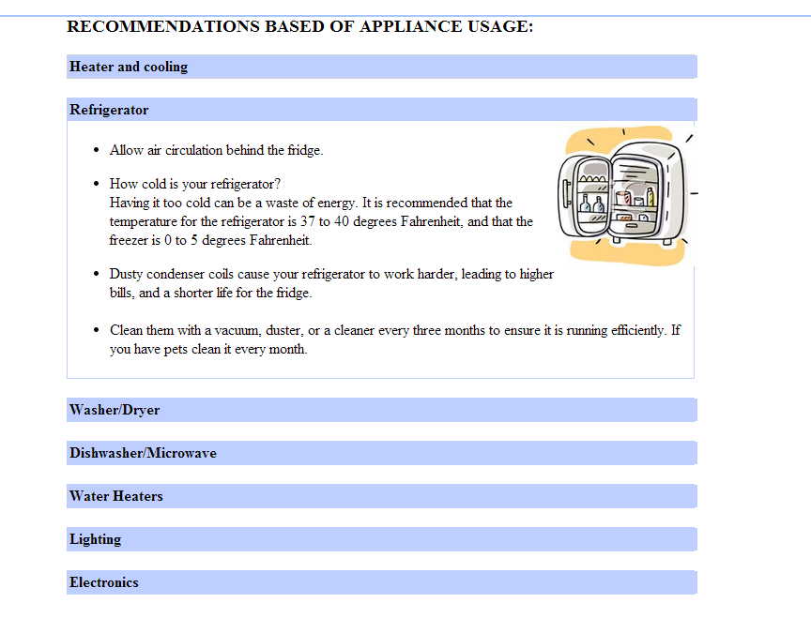

User can also choose to see the tip of the day.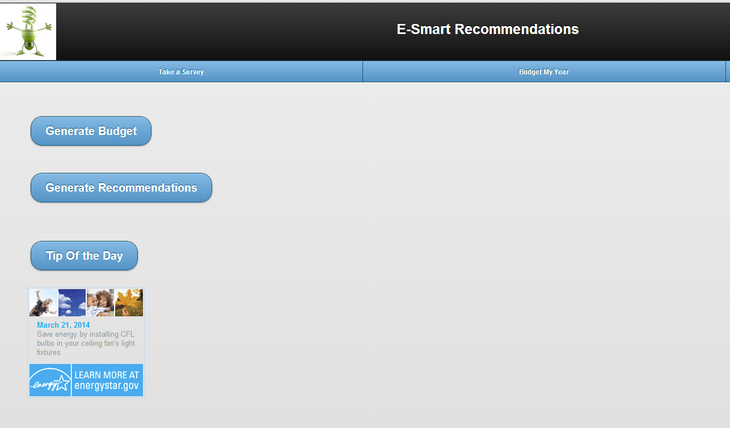

7) **Home Page:**

The user name appears at the right hand side of the page. Here **My Community** button is available.

**My Community:**

My Community is one of the features provided by the E-Smart application. The purpose of this feature is the user can compare his utility bill with his neighbors and can get reward points based on the energy utilization of all the people those live in the same community. The users bill will be compared to his neighbors who live in the same community and have the same house type and house hold size.

By looking at his reward points he can an idea about his energy consumption and can implement ways to save energy and also save money.

He can also see all his neighbor’s reward points, who live in houses similar to his house and live in the same community to get a better idea on his energy utilization.



When the clicks on **My Community** button, he will be navigated to **Join My Community** page, if he is not already part of **My Community**.

**Join My Community:**

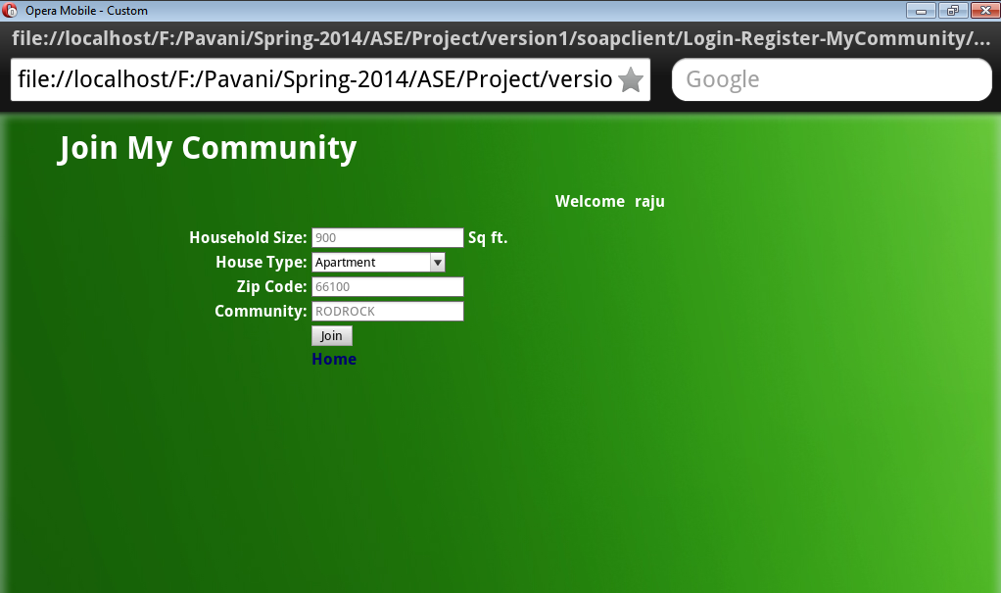

In the **Join My Community** page the user can enter his house hold size, house type and community he lives in. After filling these details, he can click on **Join** button to join My Community.

The utility bill details are stored in the MyCommunity table in sql server database.

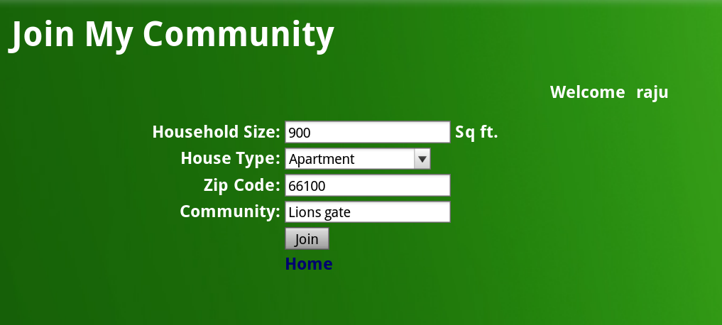

He will be navigated to the **My Community** Page where he can actually enter his utility bill details and get his reward points.

**My Community:**

The user can enter utility bill amount, utility bill month and utility bill year and click on the **Compute Reward Points** button. No to enter the house related details everytime.

**Community Reward Points:**

If the user has already computed his reward points for the current month, then those details will be loaded in this page automatically.

The user can update the details if he makes any mistake and can compute his reward points again. If the same utility bill details for that user already exists in the database, then the details will be updated with the correct utility bill amount the user entered and then computes the reward points.

The utility bill details are stored in the utility_bill table in sql server database.

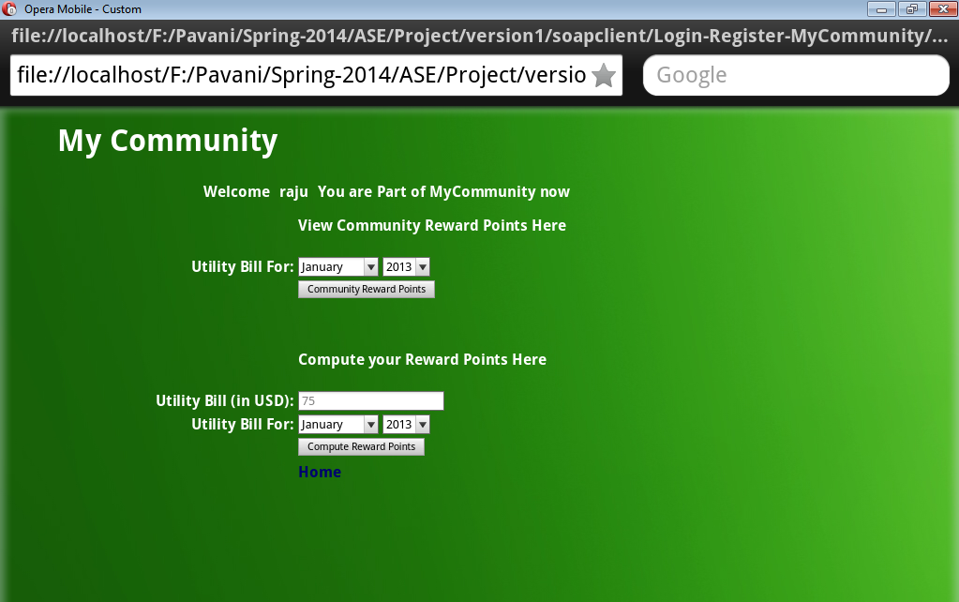

This will compare his bill amount with his neighbors and gives his reward points for that month and year.

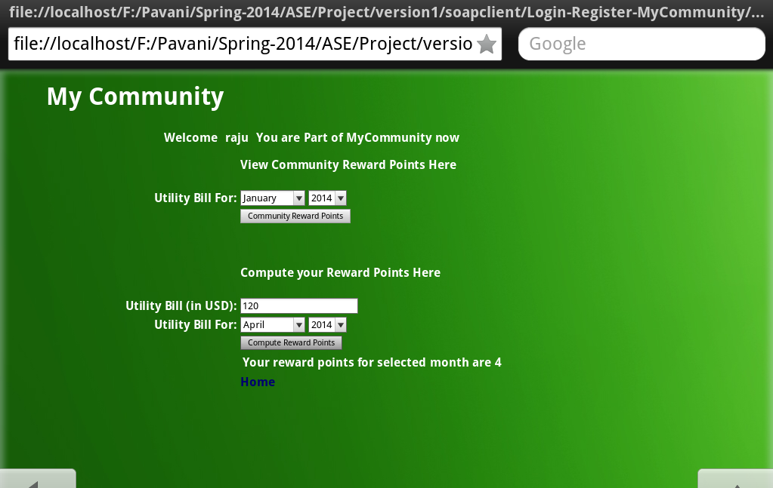

**Community Reward Points:**

The user can view his neighbors reward points who live in similar houses by selecting the month and year he wishes and click on the **Community Reward Points** button. This will display the house details and his neighbors reward points.

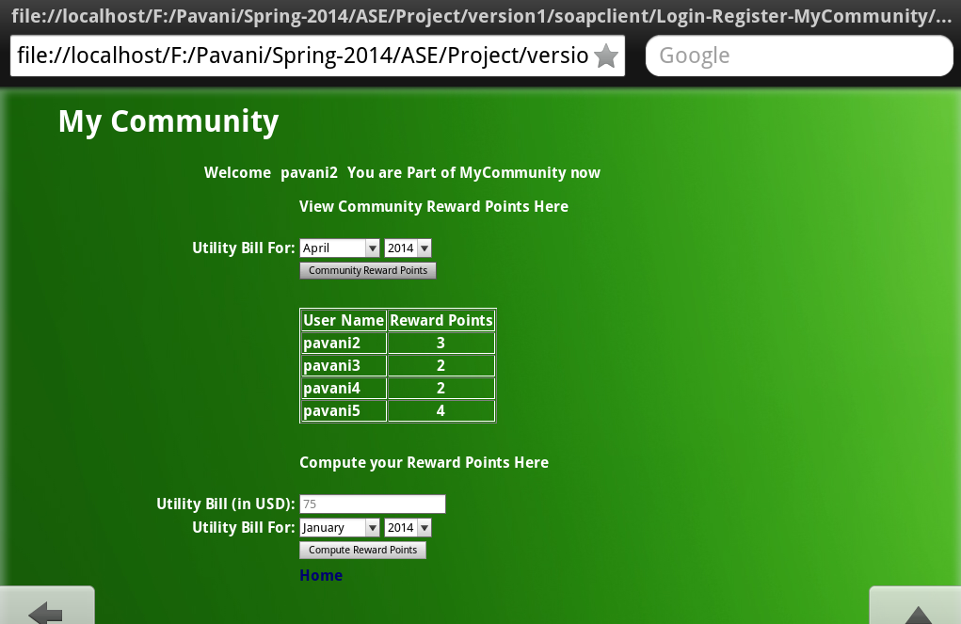

**Home Page:**

If the user is already part of My Community, he will be navigated to **My Community** page directly, when he clicks on **My Community** button in the **Home Page**. The screen navigation is as below.



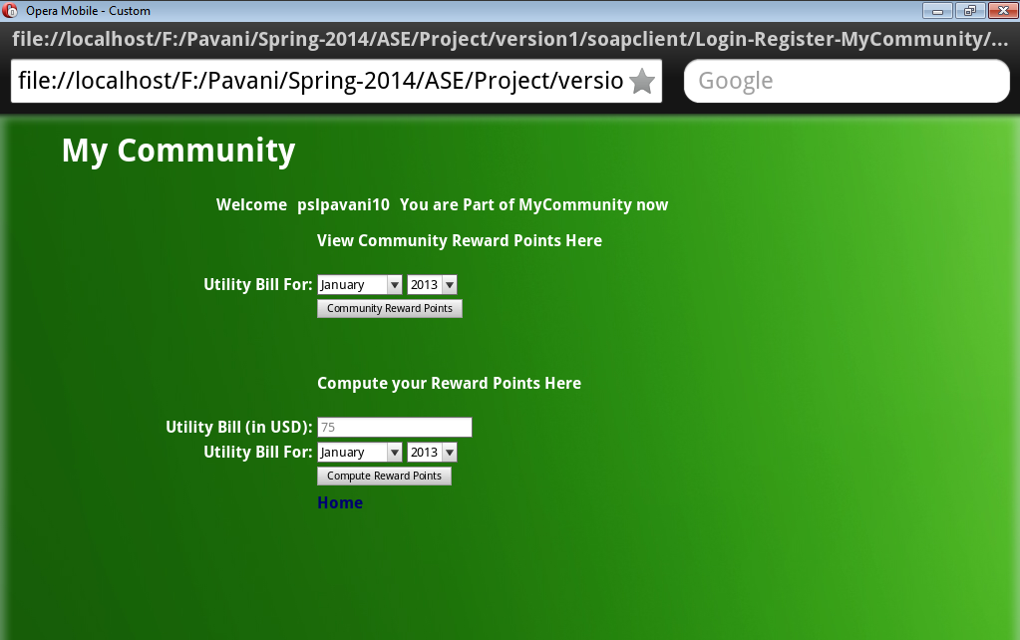

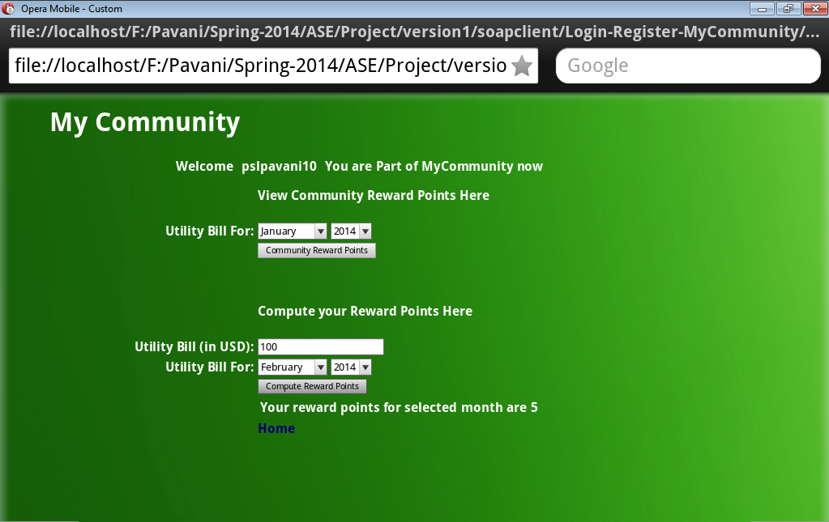

**Database details:**

**Users table:** Holds all the registered user details.

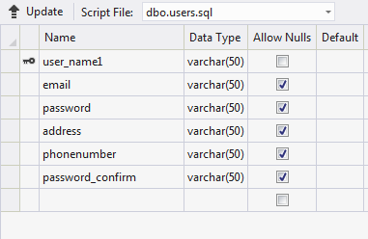

**MyCommunity table:** Holds all the users those are part of My Community.

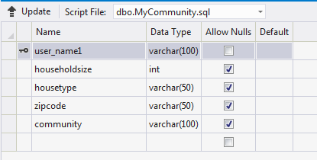

**Utility_bills table**: Holds all the utility bill details the users enter when they compute reward points.

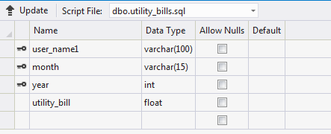

**8) Dicussion Board**

**Webservices/API:**

* The geocode function supported by the browser has been used to detect user’s current location.
* The “google.visualization.Gauge” has been used to create pie charts for the appliance utilization .
* SOAP Webservices have been used to populate forums and store user replies and create new threads.

**Design & Implementation details:**

User Clicks on the Dicussion Board image on homepage.

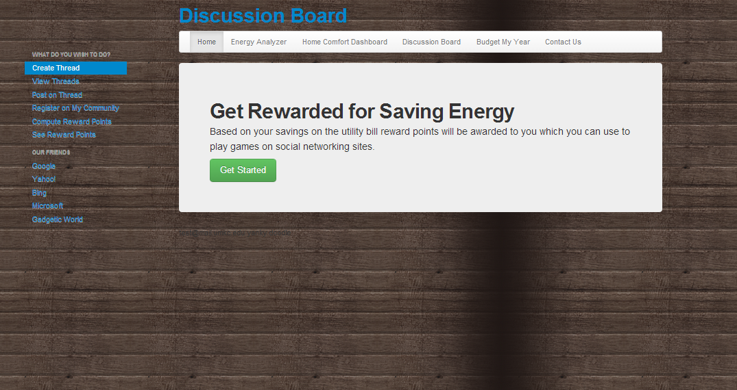

User clicks on View Threads to see all the forums talking about energy, SOAP webservice is used to pull all the related forums.

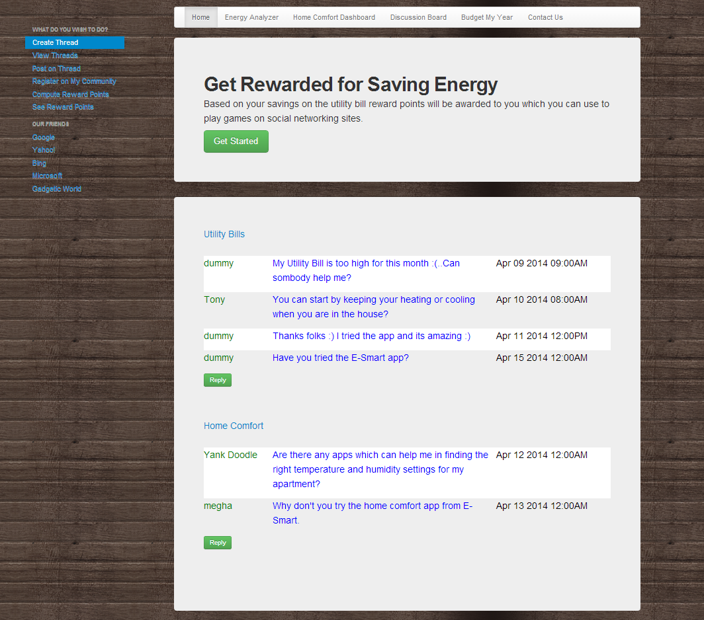

On clicking reply to a post user gets the below screen.

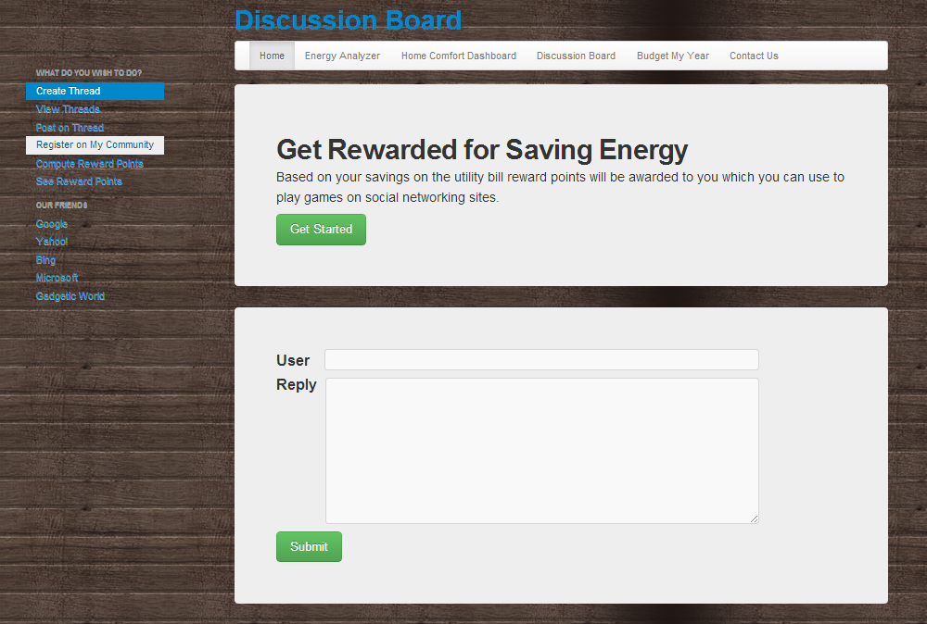

On clicking Submit the message is added to the forum in the database.

User can also create new forums by clicking on create Thread. On clicking submit the forum gets added to the database.

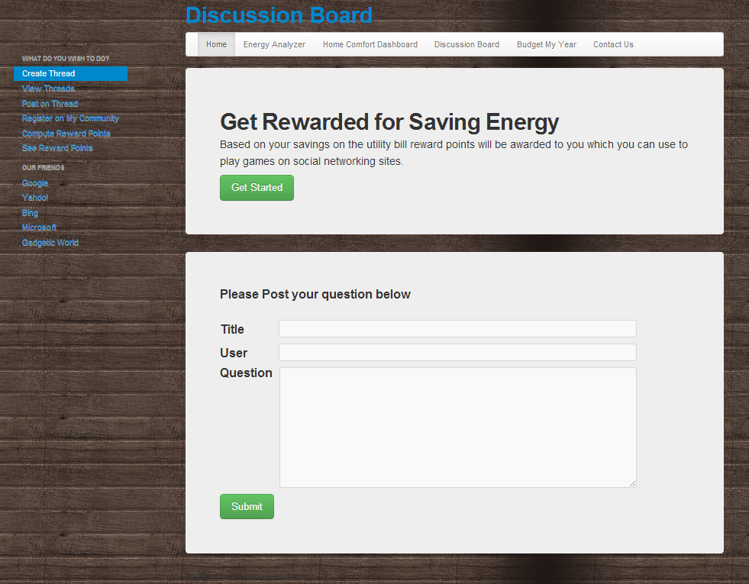

**Testing**

The unit testing has been performed manually as most of the webservices used were external.

**SOAP Web Service Nunit Testing**

The **SoapServiceInsertTest** method test the InsertTable method in the Soap Web service. The InsertTable method inserts the user details entered in the Signup page into the Local SQL server database using the Soap Web service.

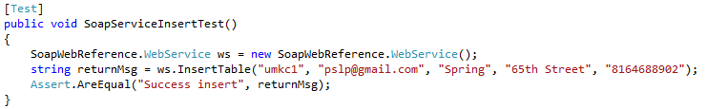

Test Results:

1.

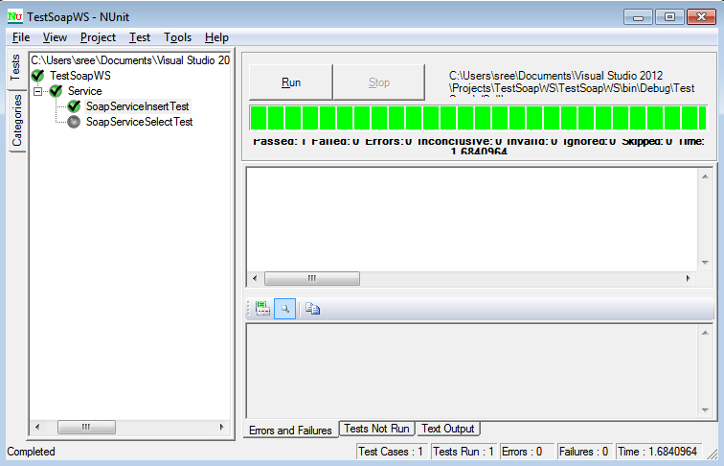

The **SoapServiceSelectTest** method test the queryTable method in the Soap Web service. The queryTable method fetches the user details entered in the Login page from the Local SQL server database using the Soap Web service for user login verification.

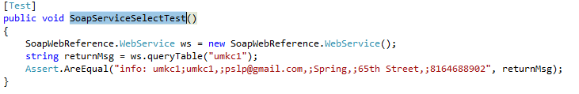

Test Results:

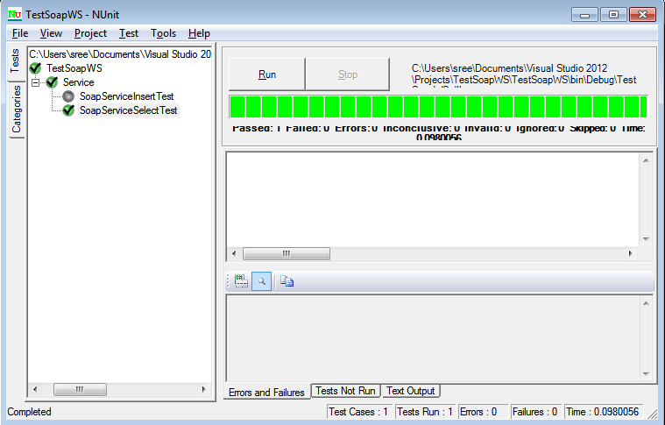

2.Below is the screenshot for NUnit Testing for getCityNotes Service methods. There are two test cases

1. For Valid city name that returns data
2. For Invalid city name that returns no data

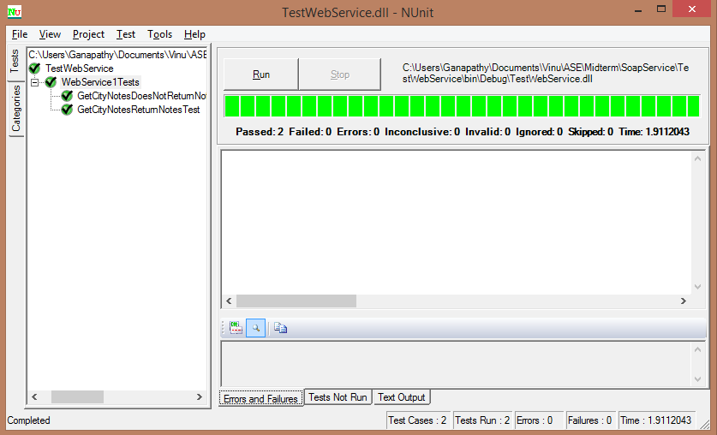

**Distribution of Work**

|  |  |  |
| --- | --- | --- |
| Responsibility | Time Taken | Person |
| My Community | 20 | Pavani |
| Homepage | 4 | All |
| Energy Analyzer and Recommendation System | 20 | Vinutha & Reshma |
| Discussion Board | 20 | Megha |
| Survey based Budget my year, Recommendation and Tip of the day | 20 | Megha and Reshma |
| Energy Efficient Homes | 18 | Pavani & Vinutha |
| Reporting & Unit Testing | 5 | All |
| Scrum Do | 2 | Reshma |

**Git Hub Repository:**

[**https://github.com/mszzf/Megha-Repository/tree/master/Project-Phase1/assets**](https://github.com/mszzf/Megha-Repository/tree/master/Project-Phase1/assets)

**ScrumDo:**

[**https://www.scrumdo.com/projects/project/esmart/iteration/92363**](https://www.scrumdo.com/projects/project/esmart/iteration/92363)

**URL for site:**

**C:\inetpub\wwwroot\aspnet_client\Group5\group5\Iteration-2\assets\html\homepage.html**